FOR IMMEDIATE RELEASE
Contact: [Name of Contact Person]
Date: [Month/Day], 2026
Folic Acid Awareness Week 2026

[YOUR ORGANIZATION NAME] Teams Up with the National Birth Defects Prevention Network to Spread the Word About Folic Acid [City, State] — Every year, about 1 in 33 babies in the United States has a birth defect. Some of the most serious birth defects are called neural tube defects (NTDs). NTDs, including spina bifida and anencephaly, affect about 1,300 pregnancies annually and are among the most severe birth defects. They can happen very early in pregnancy—often before a woman knows she is pregnant.
That’s why [YOUR ORGANIZATION NAME], along with the National Birth Defects Prevention Network (NBDPN), is taking part in Folic Acid Awareness Week 2026. This week is all about teaching people how folic acid can help prevent these serious birth defects and why it's important for women who can get pregnant to get enough every day.
Folic acid is a man-made form of folate, a B vitamin that helps your body make new cells like blood, skin, hair, and brain cells. It’s especially important in the early stages of pregnancy when the baby’s brain and spine start to form.

Why Folic Acid Is Important
- Folic acid is the only type of folate proven to help prevent neural tube defects.
- These birth defects happen during the first month of pregnancy—often before a woman knows she is pregnant.
- About half of all pregnancies in the U.S. are unplanned, so it’s important for all women who could get pregnant to get enough folic acid every day.

What Experts Recommend
Doctors say that all women who can get pregnant should take 400 micrograms (mcg) of folic acid every day. You can get this by:
- Taking a daily multivitamin with folic acid.
- Eating foods with added folic acid, like certain cereals, breads, and grains.
Even if you’re not trying to get pregnant, folic acid helps your body stay healthy by making new cells. Starting this habit now can make a big difference in your future health.

Key Points to Remember
- Women who can get pregnant should take 400 mcg of folic acid every day.
- Eat foods with folate and take vitamins to meet your daily needs.
- Folic acid is safe and works well when consumed in the right amount.
- Check vitamin labels to make sure they include folic acid.

Join NBDPN and our partners in improving health in your community. Please share the tools found in the NBDPN education and awareness toolkit (https://nbdpn.org/2025-national-folic-acid-awareness-week/).

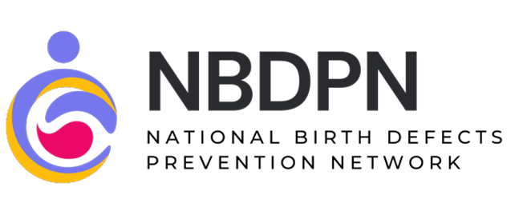

More about NBDPN
The NBDPN is a volunteer-based organization that addresses the issues of birth defects surveillance, research, and prevention under one umbrella by maintaining a national network of state and population-based birth defects programs. Learn more at nbdpn.org.

National Folic Acid Awareness Week materials and activities are an output of the National Birth Defects Prevention Network (NBDPN), in partnership with the Centers for Disease Control & Prevention (CDC), the March of Dimes, MotherToBaby, Association of Maternal & Child Health Programs (AMCHP), and others. The contents of the awareness month materials and related promotional messaging are those of the author(s) and do not necessarily represent the official views of, nor an endorsement by, state public health agencies or other NBDPN members and partners.

