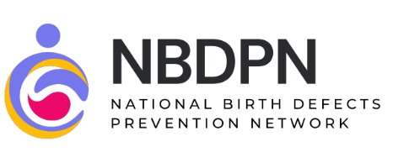

Proclamation September 2026: Folic Acid Awareness Week

WHEREAS, folic acid is an important B vitamin that helps the body make new cells and is especially important in early pregnancy when the baby’s brain and spine start to develop; and,
WHEREAS, folic acid helps stop major birth defects of the brain and spine, like spina bifida, anencephaly, and encephalocele, which can happen in the first month of pregnancy; and,
WHEREAS, not all birth defects can be prevented, but taking folic acid makes it more likely to have a healthy pregnancy; and,
WHEREAS, since about half of all pregnancies in the U.S. are unplanned, it is important for all women who can become pregnant to get enough folic acid each day; and,
WHEREAS, women who can get pregnant should take 400 micrograms (mcg) of folic acid every day, starting before pregnancy and during the early weeks, to help prevent serious birth defects; and,
WHEREAS, taking folic acid is an easy and powerful way to improve health before pregnancy.
NOW, THEREFORE, I (Governor’s name), Governor of (state), hereby proclaim September 2026 as Folic Acid Awareness Week in (state).

References
U.S. Centers for Disease Control and Prevention (CDC). (2025, 05 20). Folic Acid: Sources and Recommended Intake. Retrieved 06 26, 2025, from https://www.cdc.gov/folic-acid/about/intake-and-sources.html

